**Effects of Distance Metric on Confidence in Face Recognition Using Zernike Moments**

Ahmed J. Alia, Zahir M. Hussainb,c, Mohammed S. Mecheeb

a) MSc Candidate; Faculty of Computer Science and Mathematics, University of Kufa

b) Faculty of Computer Science and Mathematics, University of Kufa

c) Professor (Adjunct), School of Engineering, Edith Cowan University, Australia

**Abstract**

In this paper, we present a comparative study on the performance of Zernike moments for face recognition using metric measures and structural similarity measure (SSIM). For this purpose, four well-known metric measures have been used: Euclidean, City-Block, Soergel and Lorentzian. Numerical implementation show that Lorentzian distance measure outperforms other measures when using a differential performance measure based on the confidence in correct recognition versus the second possible face image candidate in the database under test.

**Keywords**: Face recognition, Moments, image similarity

**1-Introduction:**

Nowadays, the Face recognition has become a fundamental application after the advent of high performance computing. It is a multidisciplinary unresolved problem that involves several fields, especially mathematics, numerical analysis, statistics, computer science, and electronic engineering.

Zernike moments has been proposed in 1934 by Zernike[7] and the using of Zernike moments in image analysis introduced by Teague [8]. Zernike moments have been proven to be more robust in the presence of noise. Since their moment functions are defined using polar coordinate representation of the image space, Zernike moments are commonly used in recognition tasks requiring rotation invariance. Zernike moments are a good feature representation and provide more information about facial image and reduce the dimension of the feature vector leading to improve the results [5].

In this paper, we have chosen the FEI face database, which is a Brazilian face database that contains a set of face images taken between June 2005 and March 2006 at the Artificial Intelligence Laboratory of FEI in São Bernardo do Campo, São Paulo, Brazil. There are 14 images for each of 200 individuals, a total of 2800 images. All images are colorful and taken against a white homogenous background in an upright frontal position with profile rotation of up to about 180 degrees. Scale might vary about 10% and the original size of each image is 640x480 pixels. All the faces are mainly represented by students and staff at FEI, between 19 and 40 years old with distinct appearance, hairstyle, and adorns. The numbers of male and female subjects are exactly the same and equal to 100 [9]. Figure 1 shows some examples of images variations from the FEI face database.

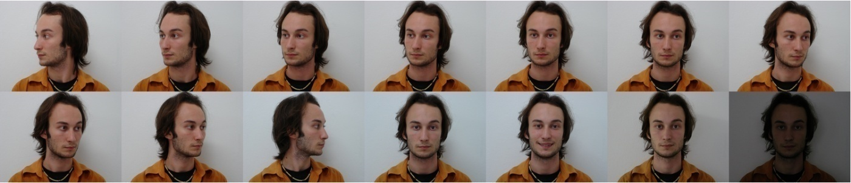

Fig.1. Examples of image variations from the FEI face database.

**2- Background**

In this section we explain theoretical principles behind this work

**2.1 Zernike Moments:**

Zernike polynomials are defined as set of orthogonal polynomials defined over the interior of the unit circle. The two-dimensional Zernike moments of order p with repetition q of image intensity function $f(r,θ)$ are defined as follows [5,6]:

$$z_{pq}=\frac{p+1}{π}\int_{0}^{2π}{\int_{0}^{1}{{R^{*}}_{pq}\left(r\right)e^{-jqθ}f\left(r,θ\right)rdrdθ, |r|≤}}1 (1)$$

where the radial polynomial $R_{pq}\left(r\right)$ is defined by the following form:

$$R_{pq}\left(r\right)=\sum_{k=0}^{\frac{p-|q|}{2}}{\frac{{\left(-1\right)}^{k}(p-k)!}{k!(\frac{p+\left|q\right|}{2}-k)!\left(\frac{p-|q|}{2}-k\right)!}}r^{p-2k} (2)$$

with $0≤q≤p$ and $p-\left|q\right|$ is an even.

Zernike moments utilize polar coordinates $\left(r,θ\right)$ inside the unit circle $|r|≤1$. To approximate and compute them in discrete form we perform a linear transformation of the image Cartesian coordinates (i, j) from the inside of the square i, j=0, 1,…,N −1 to the inside of the unit circle |r|≤1 to get the following discrete form:

$$Z_{pq}=\frac{p+1}{N-1}\sum_{j=0}^{N-1}{\sum_{i=0}^{N-1}{{ R}_{pq}\left(r_{ij}\right)}}e^{-jqθ}f\left(i,j\right) (3)$$

where

$$r_{ij}=\sqrt[2]{{x_{i}}^{2}+{y_{i}}^{2}} ;x_{i}=\frac{2i}{N-1}-1, y_{i}=\frac{2j}{N-1}-1،θ_{ij}={\text{tan}}^{-1}\left(\frac{y_{j}}{x_{i}}\right) \left(4\right)$$

However, if we implement Zernike transformation as a tested images with a chosen number of the order of polynomials and a suitable number of repetitions we will get the following data for each $p \& q$ which satisfies the condition $0≤|q|≤p$ moreover that $p-|q|$ is an even.

|  |  |  |
| --- | --- | --- |
| p | Dimensionality | Zernike moment ($Z_{pq}$) |
| 0 | 1 | $$Z_{00}$$ |
| 1 | 1 | $$Z_{11}$$ |
| 2 | 2 | $$Z_{20}Z_{22}$$ |
| 3 | 2 | $$Z_{31}Z_{33}$$ |
| 4 | 3 | $$Z_{40}Z_{42}Z_{44}$$ |
| 5 | 3 | $$Z_{51}Z_{53}Z_{55}$$ |
| 6 | 4 | $$Z_{60}Z_{62}Z_{64}Z_{66}$$ |
| 7 | 4 | $$Z_{71}Z_{73}Z_{75}Z_{77}$$ |
| 8 | 5 | $$Z_{80}Z_{82}Z_{84}Z_{86}Z_{88}$$ |
| 9 | 5 | $$Z_{91}Z_{93}Z_{95}Z_{97}Z_{99}$$ |
| 10 | 6 | $$Z_{10,0}Z_{10,2}Z_{10,4}Z_{10,6}Z_{10,8}Z_{10,10}$$ |

**TABLE 1: Low-order Zernike moments.**

Table-1 shows the information about the general vector of image which has chosen, in addition to, the adding the value $Z_{i,j}$ for each suitable $i,j$ imply to the following vector of features of the image **x**.

$$V_{x}=[Z_{00},Z_{11},Z_{20},Z_{22},Z_{31},Z_{33},………………….,Z_{10,8 },Z_{10,10}]$$

**2.2 Metric distance**

In this subsection, we consider four metrics (distance measurements) for the vectors in $R^{n}$ space to study the effect of these vectors.

For the definitions of the metrics of this study, Euclidean, City-Block, Soergel and Lorentzian distances we consider the following vectors X&Y in ${ R}^{n}$ space, where $X=\left\{x_{1},x_{2},x_{3},…,x_{n}\right\}$ and $Y=\left\{y_{1},y_{2},y_{3},…,y_{n}\right\}$

**2.2.1 Euclidean Distance [1]**

The Euclidean distance between vectors X,Y is computed by:

$$d_{Euc}\left(X,Y\right)=\sqrt[2]{\sum_{i=1}^{n}{{\left|x_{i}-y_{i}\right|}^{2}}} (5)$$

**2.2.2 Cityblock Distance [1]**

The cityblock distance between two vectors X,Y vectors is computed by:

$$d_{CB}(X,Y)=\sum_{i=1}^{n}{\left|x_{i}-y_{i}\right| (6)}$$

**2.2.3 Soergel Distance[2]**

The soergel distance between two vectors X,Y vectors is defined by the following form:

$$d_{sg}\left(X,Y\right)=\frac{\sum_{i=1}^{n}{\left|x_{i}-y_{i}\right|}}{\sum_{i=1}^{n}{max(x_{i},y_{i})}} (7)$$

**2.2.4 Lorentzian Distance[2]**

The lorentzian distance between two X,Y vectors is defined by the following form:

$$d_{Lor}\left(X,Y\right)=\sum_{i=1}^{n}{ln(1+|x_{i}-y_{i}|}) (8)$$

**. The Structural Similarity Index Method (SSIM):**

Wang et al. [3] introduced a new image quality index named Structural Similarity index method **(**SSIM**).** The SSIM measure between two images X and Y is defined by the following form:

$$SSIM(X,Y)=\frac{\left(2µ_{x}µ_{y}+C_{1}\right)(2σ_{xy}+C_{2})}{\left({µ^{2}}_{x}+{µ^{2}}_{y}+C_{1}\right)({σ^{2}}_{x}+{σ^{2}}_{y}+C_{2})} (9)$$

Where μx and μy represent the local means of images x and y, respectively, σx and σy represent the standard deviations, σxy is the cross-covariance of the two images، ${σ^{2}}_{x}$ and ${σ^{2}}_{y}$ represent the variances, respectively, while the constants $C_{1}$ and $C_{2}$ are defined as $C_{1}={(K_{1}L)}^{2}$ and $C_{2}={(K_{2}L)}^{2}$ with $K_{1}=0.01,K_{2}=0.03$ and L=255 [4].

**3– Implementation and Results**

In this work we have used the FEI data base [9]. The sample which has chosen in this study contains ten face images in two positions. We will test one reference in the row1 against all persons in row2 (See Fig. 2). Diagram1 explain the steps of the method moreover, we will find out four metric distances for each case of study (see diagram 1). However, we evaluated the SSIM for ten cases of the study. Finally, we conclude that metric measures are more robust than SSIM in addition to the fact that Lorentzian distance is more efficient than other metric measures.

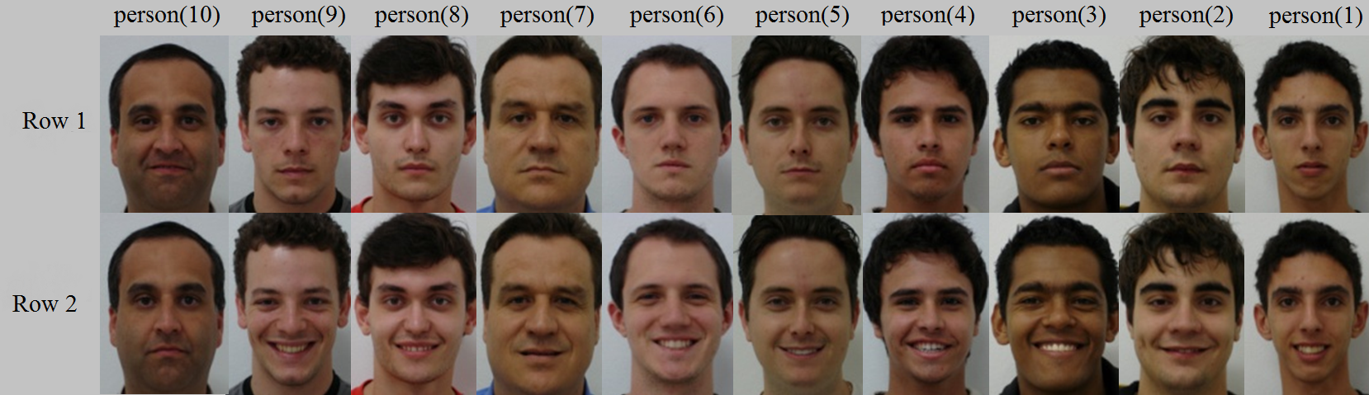

Fig.2.Sample of FEI Database

The following diagram shows the proposed work algorithm, while Table-2 shows the difference measures between the reference image (8) and other face images using different measures.

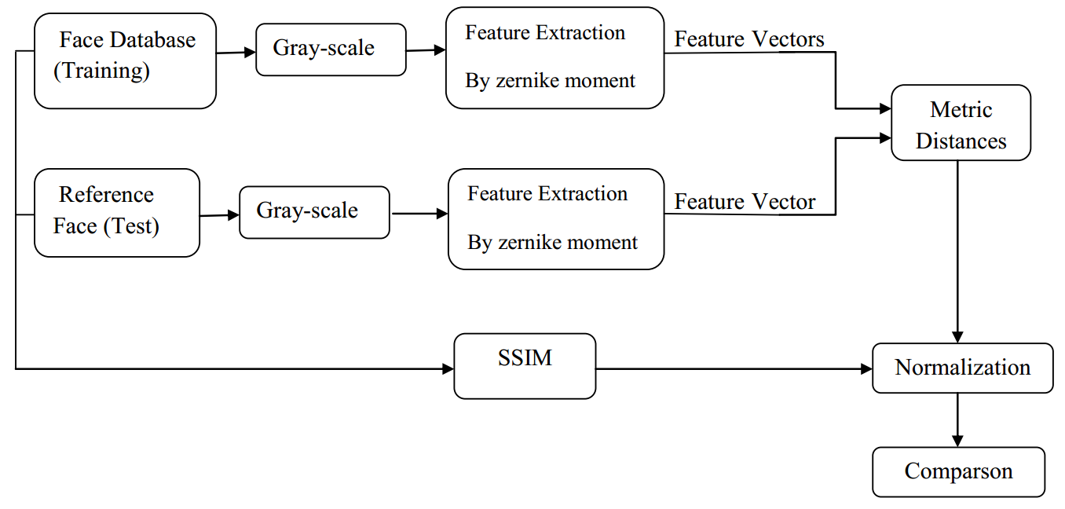Diagram (1): The Proposed Algorithm

Table-2 shows the difference measures between the reference image (8) and other face images using proposed measures as compared to the standard SSIM.

**Table-2: Distance measures with a reference image.**

|  |  |  |  |  |  |
| --- | --- | --- | --- | --- | --- |
| Pearson | Euclidean Distance | CityBlock  Distance | Soergel Distance | Lorentzian Distance | SSIM |
| 1  2  3  4  5  6  7  8 (ref)  9  10 | 0  0.4381  0.0751  0.3499  0.2927  0.3300  0.4878  1  0.1614  0.2357 | 0  0.5489  0.1874  0.4844  0.5042  0.3301  0.5936  1  0.3810  0.2683 | 0  0.3732  0.1715  0.2464  0.3868  0.0595  0.4735  1  0.3215  0.0834 | 0  0.3283  0.3042  0.2837  0.3383  0.0319  0.3249  1  0.3130  0.1041 | 0.7233  0.8099  0.7410  0.7549  0.8164  0.7465  0.7940  1  0.7270  0.7217 |

Numerical results in Table-2 and Fig.3 show that the proposed metric measures are much more robust than SSIM as they give a clearer decision about the reference person with farther distance from confusing persons. Lorentzian measure is giving best performance.



Fig.3: Comparison of Proposed Metric Distances with SSIM.

**4. Conclusion:**

In this paper we proposed four different measures for feature extraction from Zernike domain for the purpose of face recognition. Zernike moments has been utilized for preprocessing the excessive order as a feature vectors to feed the classifier stage. Four similarity measure based on metric measures classifier have been proposed. A comparison of these measures with the standard SSIM has been made using FEI face database. Results showed that the performance of the proposed similarity measures outperforms SSIM. It is worth mentioning that the Lorentzian distance measure outperforms all other measures by far.

**REFERENCES**

S.H. Cha, "Comprehensive Survey on Distance/ Similarity Measures between Probability Density Functions," International Journal of Mathematical Models and Methods in Applied Sciences, Issues 4, 2007.

C.-C. Chen and H.-T.Chu. "Similarity measurement between images," Proceedings of the 29th Annual International Computer Software and Applications Conference (COMPSAC'05), IEEE, 2005.

Z. Wang, A. C. Bovik, H. R. Sheikh, and E. P. Simon-celli, "Image Quality Assessment: From Error Visibility to Structural Similarity" IEEE Trans. Image Processing, VOL. 13, NO. 4, April 2004.

R. Dosselmann, X. D. Yang, "A comprehensive assessment of the structural similarity index," Signal Image Video Processing, Springer-Verlag, 2009.

A. N. Hashim and Z. M. Hussain, ''Local and Semi-Global Feature-Correlative Techniques for Face Recognition,'' Journal of Advanced Computer Science and Applications, Vol. 5, No. 8, 2014.

K. Sharma, G. Joshi, and M. Dutta, "Analysis of Shape and Orientation Recognition Capability of Complex Zernike Moments for Signed Gestures," IEEE International Conference on Signal Processing and Integrated Networks (SPIN), Feb. 2015.

F. Zernike, “Beugunstheorie des Schneidenverfahrens und seiner verbesserten Form, der Phasenkonstrastmethode,” Physica 1, pp. 689–701, 1934.

M. Teague, “Image analysis via the general theory of moments,” J. Opt. Soc. Amer., vol. 70, no. 8, pp. 920–930, Aug. 1980.

FEI Face Database, Image Processing Laboratory, Department of Electrical Engineering, Centro Universitario da FEI, Sao Bernardo do Campo, Sao Paulo, Brazil, <http://fei.edu.br/-cetlfacedatabase.html>, last accessed on 21-11-2014.